# Writing Learning Materials

This **Writing Learning Materials** document is developed as a guide for the Learning Team for writing all learning materials, such as the Workbooks, Help Topics and Key Learning Reviews. The first 5 pages summarize the key points to get you started on writing with a template and adding tables and screenshots appropriately. Following the summary is an extensive manual with grammar examples, detailed step by step guide to apply and adjust different types of formatting, as well as on capturing the best screenshots.

## Quick References

* Refer to **the Learning Team Style Guide** and the **CST Cerner Help Glossary** for spelling and use of common terminology.
* Remember your audience is a diverse group of healthcare professionals who may not be familiar with Cerner terms.
* Use the appropriate template for each type of learning material. Templates are found on Confluence.
  + Each template will have pre-set Styles created for learning.
* When copying from another document and pasting,

1. Copy the text,
2. Format the paragraph where you want to paste the content.
3. Right-click where you want to paste the copied content.
4. Always choose **Keep Text Only** in the **Paste Option** to avoid altering and adding unnecessary styles (found on page 16).  
   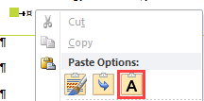

* Use present tense and active voice as much as possible.
* Use concise plain language.
* Use bold to emphasize the part of the screen you are taking action on. (eg. Review **Patient List,** Click **OK** button, etc.)
* Use bold and italic for entries learner is required to enter into the system. (eg. Type ***38.4***)
* Use underline only for hyperlink.
* Use Snagit to annotate images. Also see page 32.
  + Use red circle with number to identify step by step in a screenshot. 
  + You can use lowercase letters for substeps. 
  + Use red square with alphabet to identify parts of the screen in a legend. 

## Grammar Tips

Further detailed examples and tips are found on page 8

* Instructing the learner to click somewhere e.g. the <name> button or the <name> tab.
* Prepositions are usually used in front of nouns or pronouns and they show the relationship between the noun or pronoun and other words in a sentence.
  + Incorrect preposition up e.g. when to use “in”, “on”, “at”, and “over”.
  + Although it is not grammatically wrong to end a sentence with a preposition, it is less formal. Be sure that the meaning of the preposition is clear.
* When using pronouns, make sure it is clear as to which noun the pronoun is representing. Define what it is in a sentence when there is more than one noun (the antecedent).

## Create Learning Document

1. Find and download the appropriate template from Confluence.
2. Open the template document.
3. Save the document as a word document in accordance to the naming convention.  
   Refer to Master Tracker file under 13.0 in Confluence: <https://wiki.phsa.ca/pages/viewpage.action?spaceKey=LEAR&title=13.0+Classroom+Materials>
4. As you write your document, ensure that you apply the appropriate preset styles as needed.  
   Refer to the **Template Assistance** document if unsure which style to use.
5. If applicable, update your Table of Contents (TOC). Found on page 21.

## Upload Your Document

The following process is only applicable to printed learning materials. The process allows differentiation on the status to your learning materials: Draft, Active and Archive. You will only be uploading to draft sections. Each learning material document should have multiple versions originated from the same draft file. To finalize a draft and put forward to printing, review the completion checklist found in the Template Assistant document. For full details on how to move your learning materials to active status for print, please follow instructions on Confluence:  
<https://wiki.phsa.ca/display/LEAR/13.0+Classroom+Materials?preview=/49663242/57900470/Curriculum%20and%20Confluence%20Clean%20Up.pptx>  
  
Follow the steps below to upload to the draft sections of various printed learning material:

1. Open Confluence page under Learning 13.2, 13.5 or 13.8 to access draft areas.
2. To upload an updated version of the current draft that is already in the designated section. Lock the draft. Make sure your document name matches the current draft. Drag the new version on top of the previous version. Unlock the draft.  
   If this is the first time you are uploading the learning material, ensure it is named in accordance to the naming convention.
3. Upload your file  
   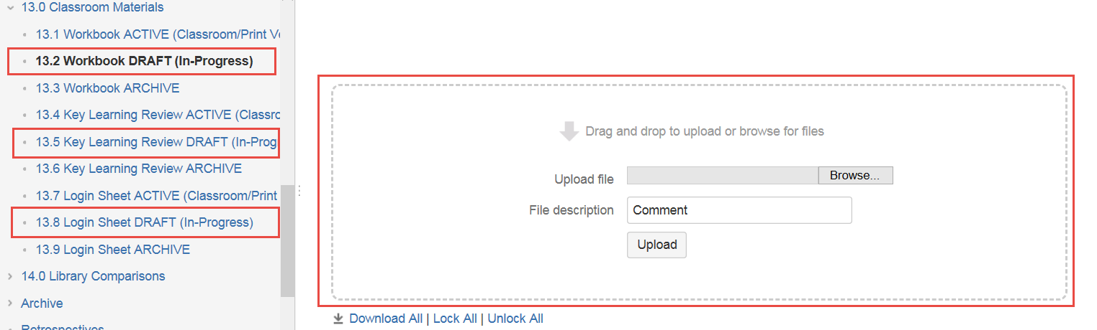
4. A new version of your file will be placed in the designated area.

## Learning Material Styles

### What are Word Styles?

In Microsoft Word, styles are a collection of pre-set formatting options for the layout of different elements in the document. Applying a style is quick and helps you use consistent formatting throughout your document.

### Styles Overview

|  |  |  |
| --- | --- | --- |
| Type | Styles | **Details** |
| Basic Text | BodyText  TableText  Table Heading | For use in all general paragraphs |
| Basic Headings | Workbook Title  Heading 1  Heading 2  Heading 3  Heading 4 | Heading 1,2 and 3 are used in Help Topics |
| Special Bullet Headings | TOC Title  Activity  Scenario  Proficiency  Introduction  View Only | Have icons in front and used as a heading to a section  Activity and Scenario style have pagination settings attached |
| Special Bullet (non Headings) | Key Learning | Have icons in front but not a heading style |
| Character (Font) | Last_Updated | Applied to selected text |
| List | BodyBullet1  BodyBullet2  BodyBullet3  Step1Number  Step2Letter  Step2Bullet  Step3Bullet  Step4Bullet  Bullet Green  LegendLetter | The numbering in the list styles identify the level/ amount of indentation.  Bullet Green is a list style with a green icon in front, generally used in listing with a table.  Body_Bullet Styles are use for teaching points, outside of step by step instructions.  Step Styles are used for step by step instructions.  Legend Letter is an alphabetical order listing system specific for use on View Only section. |

## Preparing Your Screen

To start creating your document, it will be helpful for you to display tools in Word that will assist you to apply styles and formatting.

### Show Navigation Pane

1. Under the **View** tab, ensure Print Layout is selected and check **Navigation Pane**.  
   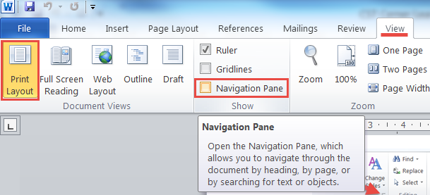  
     
   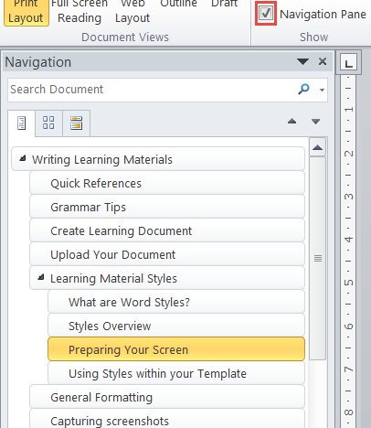

### Show Style Pane

1. Open the **Style Pane** using the **Launcher** icon under the **Styles** group on the **Home** tab.  
   Each template has formatting and standardized Styles built in. By having the Style Pane expanded, you can quickly access the list of the styles and apply to sections of the document.  
   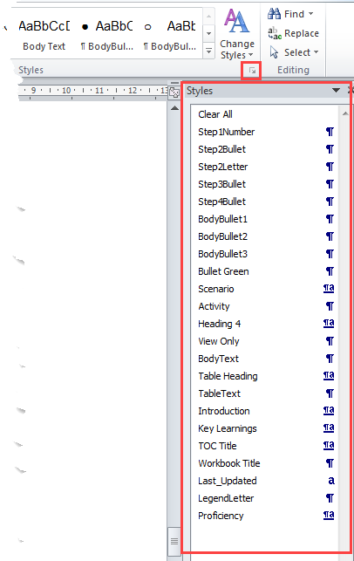
2. To preview what a Style looks like, place your cursor on the text and hover over the different styles.  
   
3. You can click on the **More** button to expand see how the styles  
   C:\Users\CWILLI~1\AppData\Local\Temp\SNAGHTML633fe99.PNG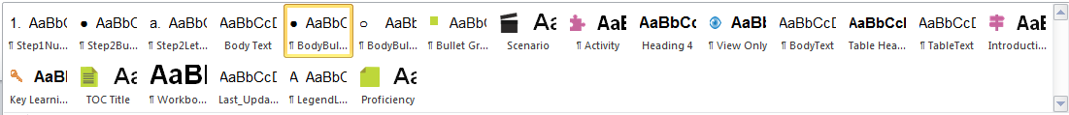

|  |  |
| --- | --- |
|  | **NOTE**: Do **NOT** Modify any of the features of the Styles. These styles will make your work easier and serve to maintain a consistent look for all workbooks. |

### Show Non-Printing Characters

1. **Show Non-Printing Characters** to help you understand the types of breaks you have used in between words and lines.  
   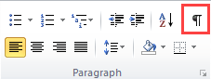  
     
     
   Popular Non Printing Characters:

|  |  |
| --- | --- |
| Types | Looks Like |
| Paragraph Marker |  |
| Line Break |  |
| Tab |  |
| Space (between words) |  |

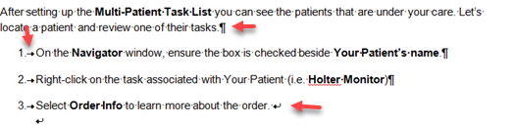

## General Formatting

* DO NOT use Bullets, Numbering, Multilevel List, Decrease Indent, or Increase Indent buttons within the Paragraph settings on your home tab. Always apply the style paragraph by paragraph by clicking the style name in the list.
* Press SHIFT+ENTER keys twice to start a new line under the same style to ensure indentation is aligned for screenshots or additional text. Detail information found on p. 16.
* Avoid using Ctrl-Enter to start a new page to avoid awkward page breaks. Major styles have pagination settings. See controlling page breaks on page 16.
* If you are copying and pasting, please paste the text only. Then, apply the style with the list.  
  For specific formatting application, please find full step by step in manual attached:

|  |  |
| --- | --- |
| Formatting | Page |
| Font | 9 |
| Paragraph | 11 |
| Bullet and Numbering List | 12 |
| Section | 13 |
| Page Break | 11 |
| Table | 16 |

## Capturing screenshots

For full details with screenshot guidance, go to page24

* Use Snagit to capture your screenshot.
* Perform screenshot adjustments (e.g. cropping) in Snagit not in Word document.
* Use the shape drawing tools in Snagit to highlight the area you are showing.
* Use the default red circle (found in the Snagit Tools tab) for any areas that need to be called out sequentially. Don’t add the red circle with number in Word document. Add in Snagit and then copy-paste the whole image to the Word document. Align the numbering on the screenshot with written instruction explained in content. Use small lower case letters if necessary to convey sub-steps.
* For identifying areas of the legend, use the square style, change the fill to red and double click on the number to change to upper case alphabets.

Writing Learning Materials Manual

* Table of Content

Writing Learning Materials 1

Quick References 1

Grammar Tips 2

Create Learning Document 2

Upload Your Document 2

Learning Material Styles 3

What are Word Styles? 3

Styles Overview 4

Preparing Your Screen 5

Show Navigation Pane 5

Show Style Pane 6

Show Non-Printing Characters 7

General Formatting 8

Capturing screenshots 8

Writing Learning Materials Manual 9

• Table of Content 10

Grammar Examples 12

Copy and Paste 13

Copy and Paste Text from another Document 13

Copy Tables 13

Copy and Paste a Table from another Document 13

Copy or Move a Table from your Current Document 14

Formatting and Styles 14

Appropriate use of Character Formatting 14

Font Formatting 15

Paragraph Formatting and Styles 15

Paragraph Formatting 15

Headings and Sub-Headings 17

Table Heading Style 18

Key Learning Style 18

Bullet and Numbering Lists Styles 18

Step by Step Instructions 20

Line Breaks 25

Page Breaks 26

Controlling Page Breaks in a Table 27

Special Tables 27

Using Table and Formatting 29

Insert a Table 29

Table, Tools and Layout tab 29

Adjusting Row, Column, Cells & Table Properties 30

Table Design 32

Customize Table 33

Table of Contents (TOC) 34

Update a Table of Contents 35

Troubleshoot Table of Content Problems 36

Section Breaks 37

Continuous Sections 38

Next page Sections 38

Using Snagit to Capture screenshots 39

Prepare Your Screen 39

Edit Image in Snagit 40

Add Boxes to Identify Parts of a Screen 40

Add Letters or Numbers to a Screenshot 41

Identify areas Areas of a Screenshot to Accompany a Legend: 43

Edit Step Values 44

Crop Images in Snagit 45

Resize Images in Snagit 46

# Grammar Examples

|  |  |  |  |
| --- | --- | --- | --- |
| Word | Grammar | When it’s used | Incorrect |
| The | definite article | Use “the” where you referring to a specific noun.  The determiner “the” is also known as an article. Articles are words that define a noun as specific/definite (“the”) or unspecific/indefinite (“a”, “an”).  Click **the** <name> button, icon, link  Click **the** <name> tab | “On the” is **not** as concise |
| On | preposition | A preposition to refer to a position on any surface (computer screen). For pages, including online pages, always use ON.  Click the Add button **on** the Orders page. | In |
| In | preposition | A preposition of place used to discuss an enclosed space. Used to indicate a specific location within a larger area  Click **in** the Search box and type...  Click the Heading **in** the Results component.  Click the **Ok** button **in** the Confirmation window.  Click Refresh **in** the top right corner |  |
| At | preposition | Click the Sign button at the bottom of the page |  |
| Over | preposition | Use over when something is covering something.  Hover your mouse over |  |
| It, Them, He, She, You, Their, Her, Him, Its, This, That, Who, Which and more | Pronouns and their antecedent | There are many different pronouns, and different types of pronouns.  A pronoun represents a noun. In grammar, the meaning of the pronoun is dependent on an antecedent (or noun) it represents.  When using pronouns make sure the pronoun is clear. “It”, “his”, “her”, “them”, “their” pronouns need to have the noun, the pronoun is representing, defined.  When there is more than one noun using a pronoun could be ambiguous.  Paul brings his dog Rex to visit patients. Rex loves to give sloppy wet kisses to the patients. | **Paul** brings his dog **Rex** to visit patients. **He** loves to give sloppy wet kisses to the patients. |

# Copy and Paste

If you are copying and pasting from another document, it is recommended that you copy and paste sections by sections.

|  |  |
| --- | --- |
|  | **WARNING**: You **MUST** paste the content as **Text** **only** to prevent copying the styles from the other document. |

## Copy and Paste Text from another Document

When you copy from one document and paste the content to another document:

1. Select text you want to copy and press **Cltr + C** or right click to select **Copy**.  
   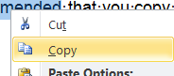
2. Go to the document you want to paste into. Move your cursor to where you want to paste the content. Before you paste the text apply the formatting you want the pasted text to have.
3. Right click to select **Keep Text Only** in the **Paste Options** popup menu.  
   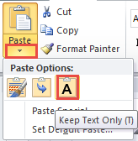
4. Apply the appropriate template styles using the **Style Pane** to the pasted text as required.

## Copy Tables

### Copy and Paste a Table from another Document

1. Copy the table from the applicable template or create a new table in the new document.
2. Select the text in the table that you want to copy.
3. Format the paragraph in the new location.
4. to select **Keep Text Only** in the **Paste Options** popup menu.  
   
5. Apply the appropriate template styles using the **Style Pane** to the pasted text as required.

### Copy or Move a Table from your Current Document

* 1. Hold your mouse point near the beginning of a table.   
       
     You will see the **Table Handle** .
  2. Click the **Table Handle** to select entire table.  
     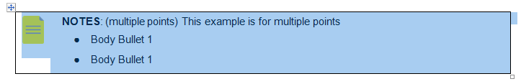
  3. Click **Cut** to move the table or **Copy**.
  4. Move you cursor to the new location. You might need to add a new paragraph.
  5. Click **Paste**. 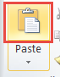

# Formatting and Styles

Word uses different kinds of formatting settings. This section will focus on the formatting required when writing Learning Materials. Most of the font and paragraph formatting is part of the styles you will use.

## Appropriate use of Character Formatting

In all Learning Materials, the font should be Arial to adhere to the CST Branding guidelines. You should not need to change the text except to bold or italicize specific words, according to the Style Guide.

* Use **bold** to emphasize the part of the screen (e.g., name of an application, button, window, or PowerPlan).
* Use **bold** to emphasize a word, such as “not”
* Use **bold** and *italics* to indicate the exact information a learner needs to type into the system,   
  e.g. Type ***38.4***
* Only use underline for hyperlinks as most identify underlined text as a link and not as part of text that require audience to pay special attention to.

### Font Formatting

* Character or font formatting is applied on a word by word basis.
* Use the **Font** group on the **Home** tab for general formatting such as Bold, Italics and Underline.  
  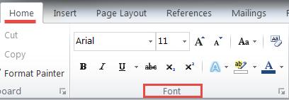
* Click the Launcher icon for full options on font style.  
  C:\Users\CWILLI~1\AppData\Local\Temp\SNAGHTML53cd5b1.PNG

#### Applying Font Styles

* Font styles display an **a**  on the right side of the style listed in the style panel.
* To apply a **Font Style**, e.g. **Last Updated** :
  + Select the **words only**, not any spaces or paragraph markers after the text.
  + Select the style from the **Style Pane**.

## Paragraph Formatting and Styles

Some styles have both paragraph and font formatting. Most heading styles fall into this category since the font size is often larger and the heading could be bold or italic and even a different colour. There is also paragraph formatting, such as the alignment and before and after spacing for the heading. Paragraph styles display a paragraph marker  beside the style name in the Style Pane Paragraph and font styles display both a paragraph marker and an **a** .

### Paragraph Formatting

* **DO NOT** use Decrease Indent or Increase Indent buttons within the Paragraph settings default on your **Home** ribbon.   
  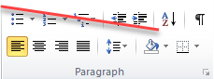
* There are a number of paragraph settings that can be applied to a single paragraph or a number of selected paragraphs.
  + Click the **Launcher** icon to set a number of settings in the **Paragraph** dialog box.  
     C:\Users\CWILLI~1\AppData\Local\Temp\SNAGHTML542b7a6.PNG  
      
    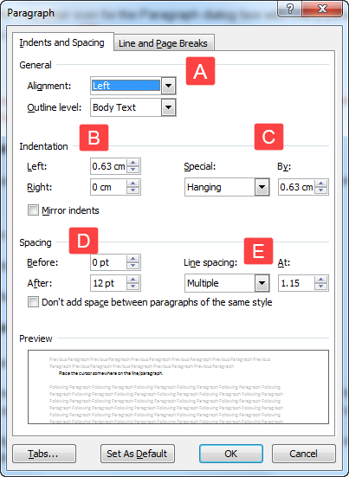

The paragraph settings in the screen shot above are for a bulleted or numbered list. It includes the following settings:

|  |  |
| --- | --- |
| LEGEND | |
| A | The **General Alignment** is **Left** aligned. |
| B | **Indentation Left**: The entire paragraph is indented .**63cm** |
| C | **Special Indentation**: **Hanging** **By** .63cm. This means that although the first line of the paragraph is indented by .63cm, the other lines of the paragraph are indented an additional .63cm. |
| D | **Spacing Before and After:**  Before the current paragraph there is no additional spacing, or buffer space. After the current paragraph there is 12pt spacing. That is like a blank line of buffer space between the current paragraph and the next paragraph. |
| E | **Line Spacing**: Is set to **Multiple** **Line** spacing of 1.15. This is the spacing between each line in a paragraph. Single line spacing is 1, so 1.15 spacing is a little more spacing that single line spacing. Other examples of Line Spacing include Double spacing. |

#### Applying Paragraph Styles

* Paragraph styles display a paragraph marker  beside the style name in the **Style Pane**.

For Paragraph Styles 

1. Place the cursor somewhere on the line/paragraph.
2. Click the style name from the **Style Pane**.

* You can use the paragraph styles on the **Quick Styles**.   
  

#### Applying Paragraph and Font Style

* For Paragraph and Font Styles ,
* That means you need to select multiple words to apply the settings to more than one word. When applying the setting to one word, you only need to have your cursor in the word.
* Heading Styles are an exception to this rule. You only need to click anywhere on the line (paragraph) and click the applicable heading style.

### Headings and Sub-Headings

Heading and sub heading styles contain paragraph and font (size) formatting.

* Only use the heading styles indicated in the template.
* Capitalize all “major” words (nouns, verbs, adjectives, adverbs, and pronouns) in the title/heading, including the second part of hyphenated major words (e.g., Self-Report not Self-report);
* Use lowercase only for “minor” words of three letters or fewer
* Some heading styles are based on Word Heading style and include a Level number. By default heading with a level number of 1 to 3 are pulled into a Table of Contents.
* Some heading styles include a graphical bullet with a hanging indent (Special Bullet Headings).
* Most heading styles include Before and After Spacing
* Heading styles usually also have some **Pagination** settings that will keep the heading with the next paragraph. This means that if the Heading is near the bottom of a page the page will break to make sure the heading stays on the same page as the first line or two of the following paragraph.
* Some heading styles will have a Page break before the Heading (e.g. Scenario and Activity).

### Table Heading Style

* Table Heading style uses bold and a small left indent. See example below:  
  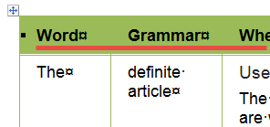
* It does not have Pagination settings.

### Key Learning Style

* Key Learnings style uses font formatting (font size and bold) as well as paragraph formatting (left indent, before and after spacing). See example below:  
  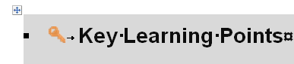

### Bullet and Numbering Lists Styles

* Bullets and numbering lists use specific paragraph formatting. It comprises of a number, letter or bullet, followed by a tab. There is a hanging indent which indents the second and subsequent lines in the paragraph to line up with the text in the first row.
* DO **NOT** use Bullets, Numbering, Multilevel List within the Paragraph settings default on your Home ribbon.   
  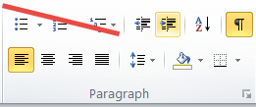

1. Place the cursor somewhere on the line/paragraph.
2. Click the style name from the **Style Pane**.

* You can use the BodyBullet or Step styles on the **Quick Styles**.   
  
* Always apply the style paragraph by paragraph by clicking the style name in the list.

#### Body Bullet Lists

* **BodyBullet1 -** use when covering teaching points that do not involve step by step instructions  
  There maybe three levels to this list (Body-Bullet-1, Body-Bullet-1, Body-Bullet-2 and Body-Bullet-3)
  + **BodyBullet2**: Each level of the multilevel list indents nicely under the previous level
    - **BodyBullet3:** Indents under **BodyBullet2**.
    - When there are more than one list item that uses the same list style (for BodyBullet 3) there is no additional spacing between the list items.

#### Step by Step Lists

1. **Step1Number** – use for each consecutive step. It is automatically numbered.

* **Step2Bullet**– use for different options within the numbered step when order is not important (indents under Step 1 Number)
* **Step3Bullet** – use for sub steps when order is not important (indents under Step 2 Bullet or Step 2 Letter)

1. **Step1Number** – use for each consecutive step. It is automatically numbered.
2. **Step2Letter** – use for sub steps **when order is important** (indents under Step-1-Number)
3. **Step2Letter**

* **Step3Bullet** – use for sub steps when order is **not** important (indents under Step-2-Bullet or Step-2-Letter)

#### Restart and Continue Numbering

When stating a new list, the new list will either continue the numbering from the previous list or the numbering will continue from the previous list. You can control how you want the numbering to work.

1. Remember to use the appropriate Step style.
2. .Right-click on the number.  A list of options will appear.

* Choose to **Restart at 1**, when the numbering has continued but you want a new numbering list.
* Choose to **Continue Numbering**, when the numbering has restarted at 1 but you want the numbering to continue from the previous list.  
  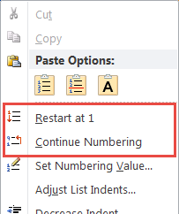

### Step by Step Instructions

When creating step by step instructions:

* Each action should be a separate step (number). This will help ensure the learner does not miss a step.
* Start with the action word to help the learner know what the step involves.
* Bold the part of the screen they will act on. This helps them locate and learn the part of the screen.
* The numbers in the image need to correspond with the numbers in the step by step instructions.
* Use Snagit to add numbers (or letters), boxes and arrows as needed. For more information about images see page 39

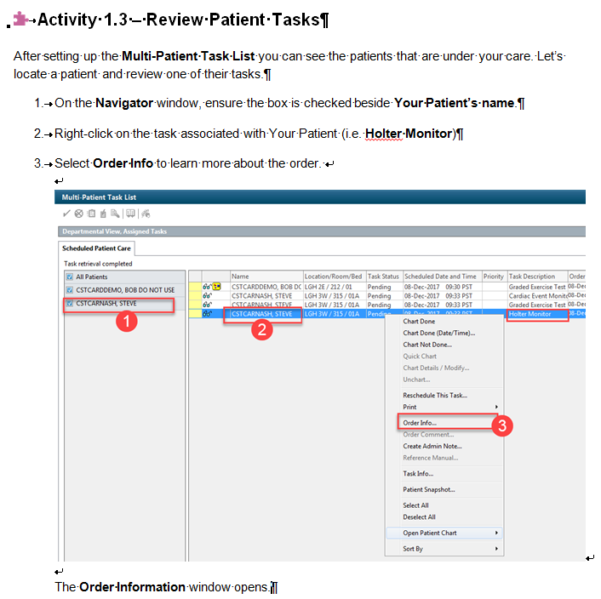

Numbers are added in Snagit. Numbers always need to match the numbered instruction.

The result of the step is **NOT** another step. It should not be numbered. IT is also lined up with the text in step 3.

#### Results Text

In the example above, the result of completing steps 3 is that the Order Information window opens.

* The result of an action can include an image, text or both.
* The result sentence should be part of step 3, **NOT** the beginning of step 4. Here we see it in on a separate line. Once again, this helps to prevent the learner from missing a step that is buried in a paragraph.

#### Lists Combining Step1Number with Step2Bullet

In this example the sub steps are listed with bullets. **Step2** indicates the sub steps are indented under the numbered items (**Step1**).

Using this combination can

* Help the learner to identify the main steps
* Each sub step can typically be done in any order
* If you add a screen shot you would not be able to annotate the bulleted list but as we see here, the image that follows, displays the results.

Example:

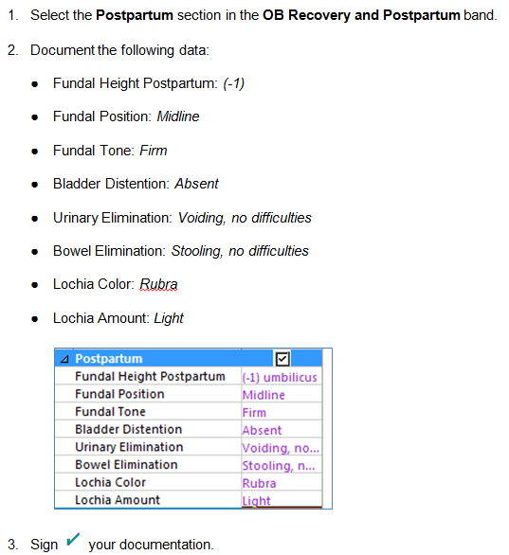

#### Combining Steps with Ordered Sub Steps

In this example the sub steps are listed with a lowercase letters. **Step2** indicates the sub steps are indented under the numbered items (**Step1**).

Using this combination can

* help the learner to identify the main steps
* list the sub steps in a particular order
* An image can be annotated with the lowercase letters in red circles, to identify where the learner needs to click for a given set of sub steps.

Example:

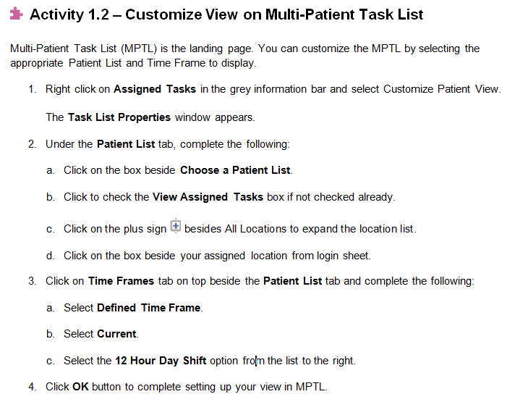

#### Lists and Annotated Screenshots

* Use red circles with numbers to annotate the image. Be sure to do this in Snagit, not Word.
* The numbered steps should align with the numbers in the red circles.
* Be sure not to put too many steps on one screenshot as it could be hard to read. In this example there are two screen shots of different screens.

Example:

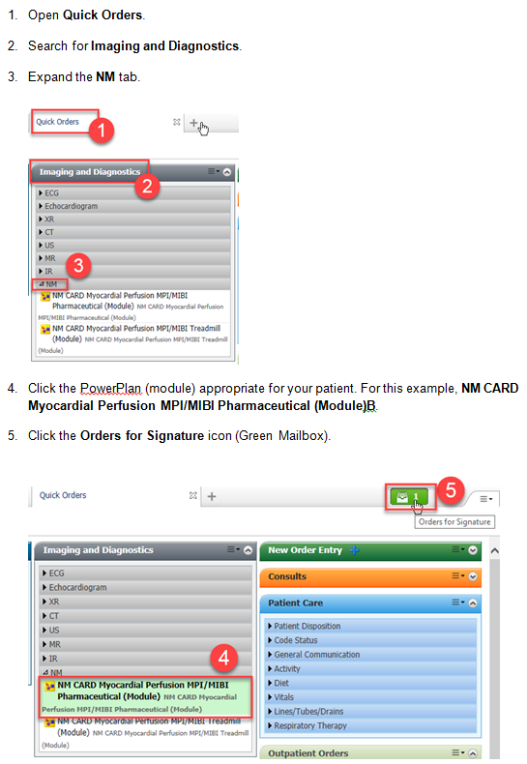

# Line Breaks

In this image the **Show/Hide** button is toggled on to show the **non-printing characters** such as tab spaces, enters (paragraphs) and line breaks.

* Use **Shift + Enter** to create a line break within a paragraph. This will line up images and additional lines of text that fall under a specific step.

Example:



# Page Breaks

Managing page breaks can be done in a way that saves you time as you edit and move around information. It is best **NOT** to use **Ctrl + Enter** to start a new page to avoid awkward page breaks. You should **NOT** need to press the Enter key until you have a new page.

* Some templates include an automatic page break before certain heading (**Page break before**) such as **Scenario** and the **Activity** styles.

The Paragraph **Pagination** settings can be used to control where page breaks occur. These settings can be found on the **Line and Page Break** tab in the **Paragraph** dialog box.

1. Click the **Paragraph Dialog Launcher** icon (diagonal arrow) on the **Home** tab. C:\Users\CWILLI~1\AppData\Local\Temp\SNAGHTML9e7476.PNG
2. Navigate to the **Line and Page Break** tab.  
   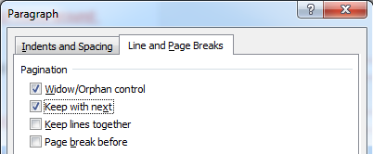

* When you want to prevent a page break to occur between two paragraph (e.g. between a step and the image that illustrated the step), click the first of the two paragraphs and choose **Keep with next**

|  |  |
| --- | --- |
|  | **NOTE**: this does not mean that all of the next paragraph will stay with the previous paragraph. |

* You can apply the **Keep with next** setting for a few paragraphs (steps) at a time. However, be careful that you do not leave this setting turned on as you will find that you could create a blank page as too much information has been set to keep together.
* When you want a paragraph to prevent a page break in the middle of a paragraph, choose **Keep lines together**.
* The **Widow and Orphan control** setting is on by default. This setting prevents a page break before the last line when there a only a few words on the last line. Word will take the second last line and put it with the “orphaned” words. You rarely need to turn this off.

## Controlling Page Breaks in a Table

By default, a page break can occur within a row.

* When you want the content of a row to stay on the same page, uncheck the **Allow row to break across pages** checkbox on the Row tab of **Table Properties**.   
  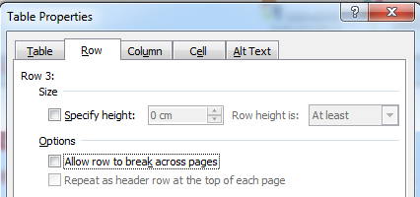
* The Table Heading style has the **Keep with Next** is turned in the Paragraph dialog box on the Line and Page Breaks tab. This will keep the first row of a table on the same page as the second row in the table.  
  

#### Repeat Table Headings

When tables continue on another page you can select the header row or rows and turn on the Repeat as header row at top of each page checkbox

1. Click in the heading row or select two rows if applicable.
2. Turn on the **Repeat Header Rows** button on the **Layout** tab.  
    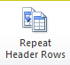

## Special Tables

There are two variations of tables that are used in a few of the templates. They are called the Note table and the Warning table.

Note Tables

**NOTE** tables can be used to provide:

* additional information (e.g. something that happens downstream)
* information about an exception
* an alternative method
* a valuable tip
* To avoid accidentally changing the format, it is recommended that you copy these tables to wherever needed. To learn how to copy and paste a table, go to page 9.

Be strategic when determining where to placing NOTE tables. The learner needs to go through the “happy” path before learning all about the exceptions, troubleshooting tips.

Avoid placing the box in the middle of set of steps that go together, e.g. a few steps that go with a screenshot.

* If a **NOTE** table contains more than a few paragraphs or points, it might be better to create a new heading and section to detail the exception or troubleshooting tip. You can refer to the heading in the step by step instructions.

Examples of Note Tables

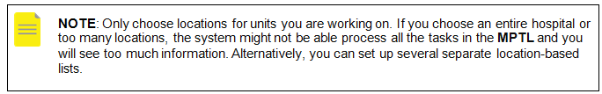

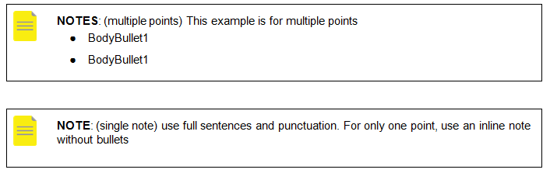

#### WARNING Tables

A **WARNING** table is a good way to bring the learner’s attention of some information that can cause problems such as:

* Critical clinical information
* Critical information that the system requires
* Include a brief rational of why the issue is important.
* It is best to copy and paste additional NOTE boxes to maintain the formatting. . See page 15.

Examples of Warning Tables

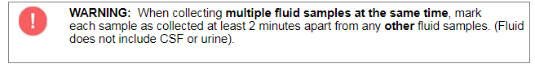

|  |  |
| --- | --- |
|  | **WARNING**: (multiple points)   * For only one point, use an inline note without bullets * This example is for multiple warning points |

## Using Table and Formatting

### Insert a Table

1. To insert a table, click the Table drop-down arrow on the Insert ribbon.
2. Click and drag to select the number of rows and columns you want in the table. 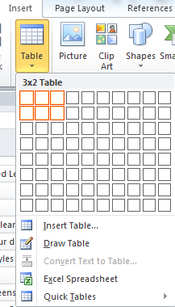

* For information on preventing a page breaks in a row, see page 12.

### Table, Tools and Layout tab

* Your cursor must be in a table to be able to view this tab. Select Layout.  
  
* Click **Properties** for more options. 

#### Inserting Rows and Columns

* Use these buttons found in the Rows & Columns section under Layout of the Table Tools tab to insert rows and columns.  
  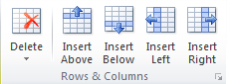

#### Deleting Rows and Columns

* Use the **Delete** drop-down arrow under the Rows & Columns group to delete a row, column, cell or the entire table.
* Your cursor must be in a specific row or column to **Delete** a row or column.
* You can delete multiple rows or columns by selecting the rows or columns you want to delete.  
  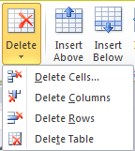

### Adjusting Row, Column, Cells & Table Properties

* Click Click **Properties** for more options. 

#### Row Settings

* Each row can be formatted by clicking in Row tab within Table Properties.
* You can format the next or previous rows by using the button shown at the bottom.
* Row settings include:
  + Row Size (height): Row height can be set to be At Least (no shorter than) the height entered or Exactly (no more or less than) the height entered. Be careful as the Exact setting can cut off text.
  + Turning off the Allow row to break across pages can add a blank space on the previous page.  
    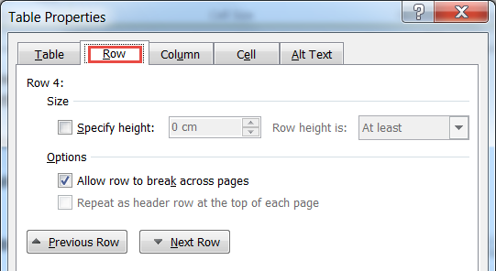
* See information on adding page break in row on page 12

#### Column Settings

* The column width can be set to be exact.
* Click Next or Previous column buttons to modify the column width.  
  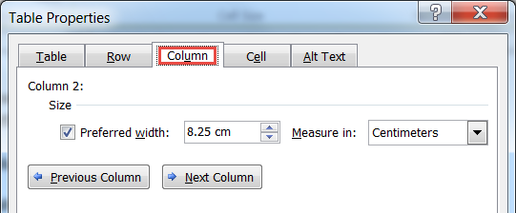
* **TIP**: This can be handy when you insert a column and your table “falls” off the page.

#### Cell Settings

|  |  |
| --- | --- |
| The vertical alignment can be applied to the selected table cell or cells. |  |

#### Table Settings

|  |  |
| --- | --- |
| * A number of settings are available in this tab:   + Size (table width)   + Alignment   + Text Wrapping (please keep setting at None) |  |

### Table Design

Some templates have a default Design applied to a new table. Designs are available on the **Design** tab. Cell Shading and Borders can also be set from the Table Properties window.

The **CST Table** design is the default design for many templates.

|  |  |  |
| --- | --- | --- |
| Table Heading | Table Heading | Table Heading |
| Table Text | Table Text | Table Text |
| Table Text | Table Text | Table Text |

|  |  |
| --- | --- |
| 1. Click anywhere on the table. 2. Select **Design** tab under **Table Tools**. 3. Hover to make sure you have located the **CST Table** Design. Click to apply. 4. You can turn off the shading for the header row by deselecting **Header Row** check box on the **Table Style Options**. |  |

### Customize Table

|  |  |  |
| --- | --- | --- |
| Borders | Applies a border (line) for borders above, between and below to a table, or selected cell(s).  Choose the style, colour and width of the border and then click the different buttons to apply the style to one or more line. You will need to re-apply the line if you want to change the style. |  |
| Shading | Applies cell shading to a table or selected cell or cells.  Shading can also be done on the Table Tools Design tab. | C:\Users\CWILLI~1\AppData\Local\Temp\SNAGHTML56c07aa.PNG |

# Table of Contents (TOC)

A Table of Contents (TOC) is a type of Reference in Word. By default, a Table of Contents will insert the text where Heading 1, Heading 2 and Heading 3 styles have been applied. In some templates there are Special Heading styles that are based on these heading styles. They will also get pulled into the Table of contents.

1. Prepare a page near the beginning of your document where you want to add the table of contents.
2. Enter a Heading, e.g. Table of Contents. If you do not want the table of contents title, do not apply a style based on Heading 1, Heading 2 and Heading 3 styles.  
     
   As we have seen, these heading styles have a Level number. The Level number controls the indentation of the different headings listed in the TOC.
3. Click the Table of Contents button on the References ribbon.
4. Choose the format for the table of contents.  
     
   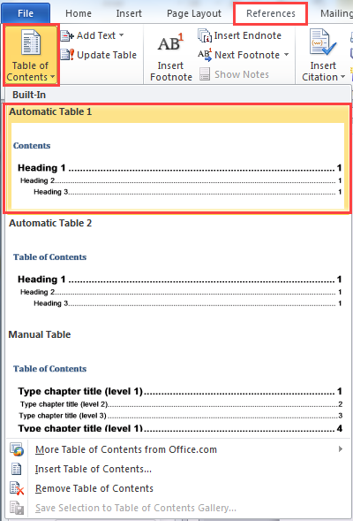  
     
   A table of contents field is inserted with the headings.

|  |  |
| --- | --- |
|  | **NOTES**:   * Table of Contents is not automatically updated. Right-click the TOC and select update table at the top left corner. * Only first three heading levels are displayed in the TOC. |

## Update a Table of Contents

When you edit a document, you usually need to update the Table of Content field to ensure the headings and page numbers reflect changes.

1. Right-click the Table of Contents field.
2. Choose **Update Field**.

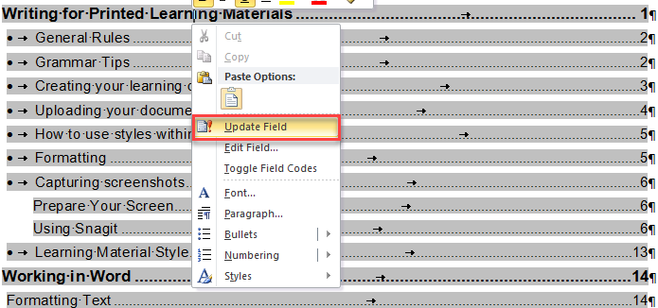

1. Select **Update entire table** and click **Ok**.  
     
    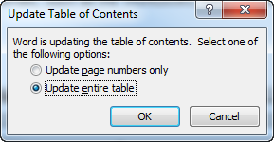
2. Review the TOC. Make sure that additional information is not included.

## Troubleshoot Table of Content Problems

If you see text that is being pulled into the TOC that should not be there, formatting errors have been made. In this example there are two formatting errors that need to be fixed.

* Some text in a section has a heading style applied (Introduction).
* There is also an image in another section has a heading style applied (Activity)

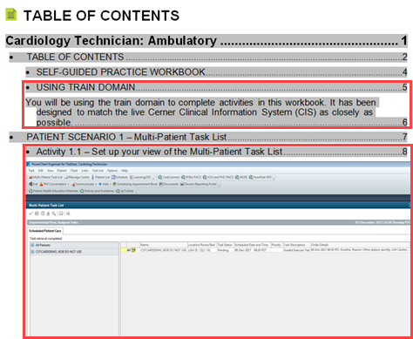

1. Check the styles that have been applied to the text by selecting paragraphs and seeing which style is highlighted in the **Styles Pane**.
2. Apply the correct style for each of the paragraphs, including the blank paragraphs that need to be corrected.
3. Update the Tables of Contents to make sure all of the problems have been corrected (see page 7).  
   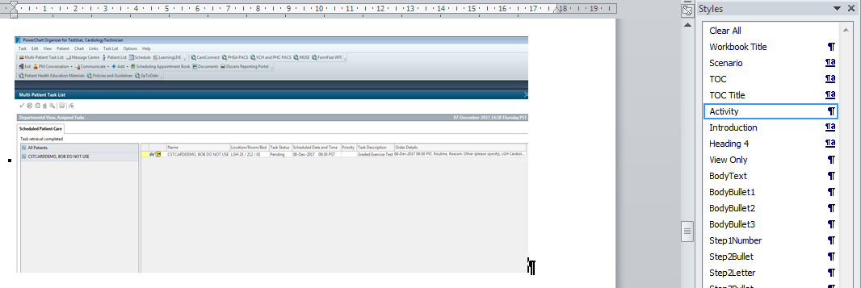

# Section Breaks

A Word document may have section breaks, where in most larger templates (eg. Workbook template), have been pre-built into the styles. There are two main kinds of sections. **Continuous** pertains to part of a page or pages. **Next Page** includes an entire page or pages.

1. To insert a section, click the **Breaks** drop-down button on the **Page Layout** ribbon.  
   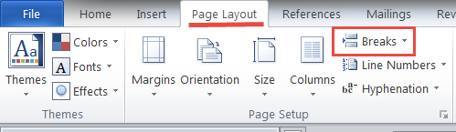
2. Choose the type of section that you need.  
   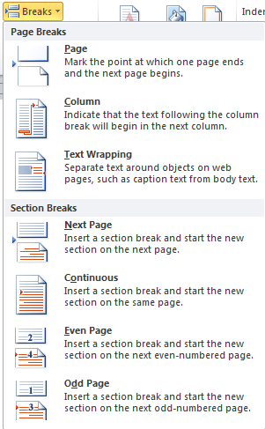

## Continuous Sections

Continuous section formatting includes column numbers (default is one column) and margins for a specific area. You should not need to modify the margins.

## Next page Sections

Next Page Section formatting controls:

* Page orientation (landscaping and portrait)
* Paper size
* Headers and Footers.
* Some margin settings are applied to entire pages, e.g. Mirrored.

# Using Snagit to Capture screenshots

Getting good quality screenshots improve how well the learner can see the images and therefore learn the content.

### Prepare Your Screen

Before grabbing the screenshot:

* Place the screen on a large monitor, rather than the laptop monitor. The large monitors have a much higher resolution.
* When you want to take the screenshot of the whole window of the clinical application:
  + Decrease the size of the window as much as possible
  + Adjusting the width of the columns
  + Collapse any unnecessary widget or category on the screen

#### Before & After Example of Preparing Your Screen

|  |  |
| --- | --- |
|  |  |

* When you only need to capture part of the screen:
  + Only capture the part of the screen that you need to.
  + If you need to crop the image, crop the image in Snagit

### Edit Image in Snagit

* Perform screenshot adjustments (e.g. cropping) in Snagit not in Word document.
* Perform all edits, such as adding numbers, boxes and call outs in Snagit and then copy-paste the whole image to the Word document.

### Add Boxes to Identify Parts of a Screen

* Use the shape drawing tools in Snagit to highlight the area you are showing.  
    
  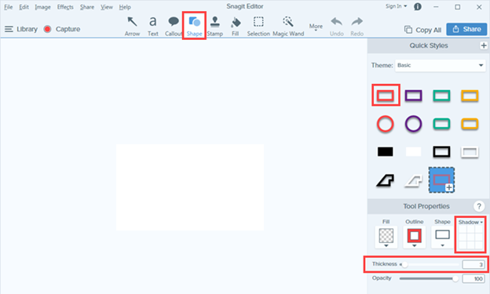

|  |  |
| --- | --- |
|  | **NOTES**: For older versions of Snagit:   1. Select Drawing Tools on the toolbar. 2. Choose the red box. |

### Add Letters or Numbers to a Screenshot

Use the default red circle  (found in the Snagit Tools tab) for any areas that need to be call out sequentially. **Don’t** add the red circle with number in Word document. Then copy-paste the whole image to the Word document. Align the numbering on the screenshot with steps explained in contents. Use small lower case letters if necessary to convey sub-sets.

1. Select **Step** from the **More** drop-down menu.
2. The default shape is a red circle with numbers (1, 2, 3) in the middle.
3. Toggle off the **Shadow**. This improves the crispness of the image.  
   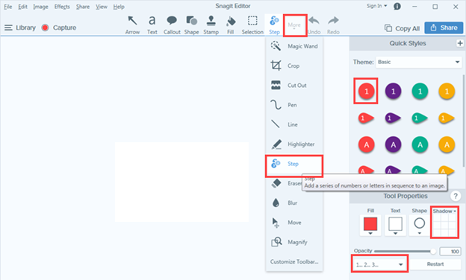

|  |  |
| --- | --- |
|  | **NOTES**: For older versions of Snagit:   1. Select the red round shape on the toolbar. |

#### Create Lower Case Letters for Sub Steps

1. Click **Step** from the **More** drop-down menu.
2. Click the drop-down at the bottom of the screen to change the default numbers to lowercase letters; a, b, c.   
   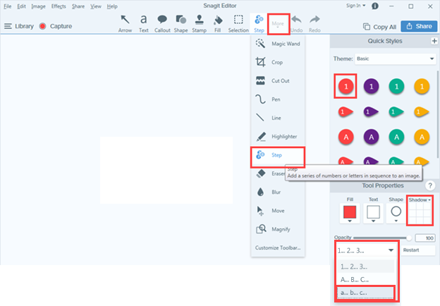

|  |  |
| --- | --- |
|  | **NOTES**: For older versions of Snagit:   1. Select the red round shape on the toolbar. 2. Double click on the number and change the value to a lowercase letter. |

### Identify areas Areas of a Screenshot to Accompany a Legend:

1. Choose **Step** from the **More** menu.
2. Change the values to A, B, C.
3. Select the square Shape.
4. Resize the square if needed **before** you create the other letters, to make them all the same size.  
   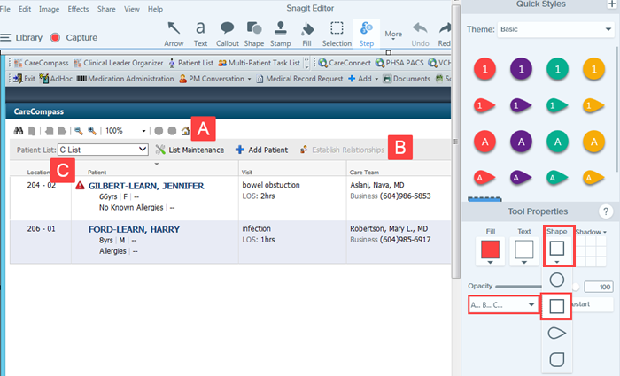

|  |  |
| --- | --- |
|  | **NOTES**: For older versions of Snagit:   1. Select the square shape on the toolbar. 2. Change the fill to red and double click on the number to change to alphabets in capital form. 3. Double click on the number to change to alphabets in capital form. |

### Edit Step Values

1. To edit a value, right-click on a circle and choose **Edit Value**.
2. Enter the new value.
3. Then type in the value. Remember the step letter or number should correspond with the written instruction.
4. Click the checkmark.
5. If you add more more numbers, Snagit will continue the sequence fron the value you entered.  
   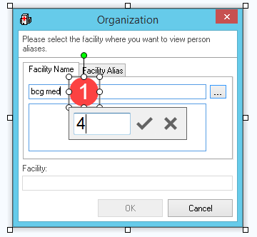

### Crop Images in Snagit

Capture just the part of the screen that you need to avoid needing to crop unnecessarily and improve the quality of your image.

If you need to crop an image use Snagit, not in Word.

1. Select **Crop** from the **More** drop-down menu.
2. Drag any of the eight sizing handles  to reduce the screen area as needed.
3. Click **Crop** button.  
     
   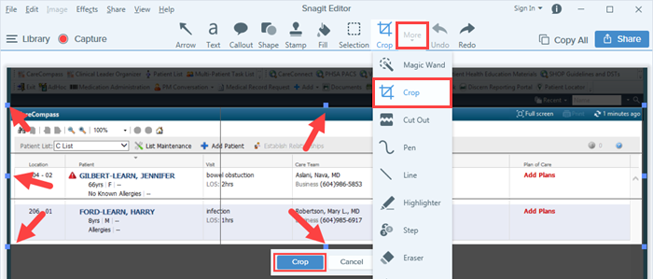

### Resize Images in Snagit

An image can be resized in Word as long as it is not more than 1500 pixels. Resize larger images in Snagit. Make sure you have resized the CST Cerner window to avoid really large images to improve quality (see page 39).

The image size can be determined at the bottom of the Snagit winow.

1. Click the box that displays the image size. A box opens.  
   Notice the lock by the **Width** and **Height** fields. The lock means that the new size with maintain the same ratio of height and width. Keep the Lock selected.
2. Enter either a new height or width.
3. Click **Apply**.  
   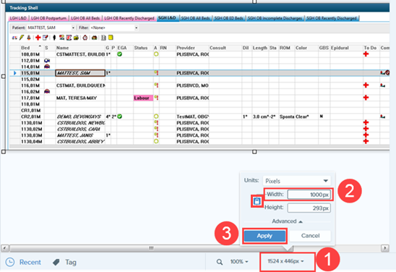

#### Reduce White Space in a Screenshot

Another way to improve a screenshot, and reduce the space in the document is to use the **Cut Out** tool. It is important to cut out blank parts of the screen.

1. Select **Cut Out** from the **More** drop-down menu.
2. Choose the **Horizontal Cut Out** **option** or the **Vertical option**.
3. Click and drag the area to cut out. When you let go of the mouse the selected area will be removed.  
     
   